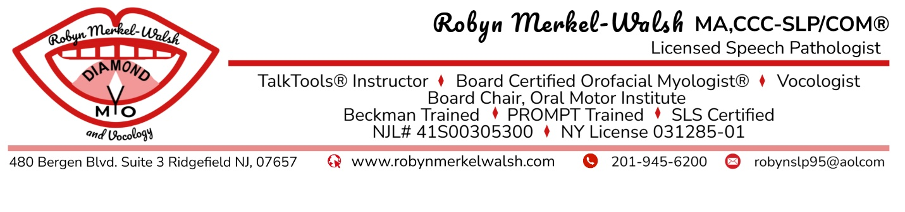Evaluation Procedures
*This is a step-by-step guide to scheduling your evaluation. Please read it carefully. *
Evaluations are completed in two parts.
Part 1: Virtual parent or patient interview through Theraplatform. This is a 30-minute meeting to review records and prepare for the in-person visit. The patient does not attend unless they are an adult.
Part 2: In-person evaluation is at the Ridgefield office with one parent/caregiver and child, or the adult patient. The length of this visit depends on age, cognitive status and needs of the patient and is priced accordingly. This may be booked as two 45-minute sessions or one 90-minute session depending on availability and client needs.
STEP ONE
Theraplatform: Set Up/Registration
1. ASAP: Email robynslp95@aol.com with your preferred email, your preferred cell phone number, and the patient’s full legal name. This information will be used to register your account.
2. You will receive a welcome email from Theraplatform. Follow the link to create a username and password. Write it down so you do not forget it. If you do not see the email, check your spam or junk folder.
3. Log in to Theraplatform and complete all online forms. Fill out demographics, billing, HIPAA/privacy notices, and consent forms. Be sure to list the patient’s name when asked (and not your own unless you are the patient).
4. Do not delete your appointment notification email as it has a direct link to your virtual session. If you do delete it, sign in to the Theraplatform with your password. The link is https://robynmerkelwalsh.theraplatform.com. Click “Join Session” and choose the correct appointment date and time.
STEP TWO
Paperwork and Deposit
Appointments cannot be confirmed until both the required paperwork and the deposit have been received. Please complete these steps within seven days.
1. Go to www.robynmerkelwalsh.com
2. Click on the “Scheduling” page at the top right.
3. Select “Office Forms”.
4. Print the forms via computer (or open as word documents on your cell phone) and complete the following forms: “case history” (choose pediatric or adult), “privacy forms”, and “evaluation contract”. (Please do not fill out “therapy forms”.)
5. Mail these forms with a $150 deposit written to Robyn Merkel-Walsh by check or money order. The address is 480 Bergen Blvd., Suite 3, Ridgefield, NJ 07657. Please do not require a signature, as I am not in the office until after school hours.
6. Any additional evaluations, IEPs or pertinent data can be uploaded to the Theraplatform under “attachments” in a PDF format.

NOTE: Once your forms and deposit are received, you will be emailed available dates for your evaluation, and we will schedule at mutually agreeable times.
STEP THREE
Virtual Intake Meeting
1. This meeting is for parents only (or adult patients), to review case history and discuss concerns & evaluation procedures. This is also the time to answer any questions that you may have.
2. You will join the meeting using the Theraplatform link provided when scheduled or log in via password and click “Join Session” and chose the correct date/time.
3. Please be in a quiet space with good lighting, a steady camera, and a strong Wi-Fi connection.
4. Chrome or Firefox work best with Theraplatform.

NOTE: Once this meeting takes place, your therapy deposit cannot be refunded as I will have reviewed records, plus set aside time for the intake.
STEP FOUR
In-Person Evaluation
1. Bring all items listed on your evaluation contract, including requested food, drink, utensils and payment by check/money order/cash ONLY. Credit cards are not accepted for evaluations.
2. The list of required items can be found at: https://www.robynmerkelwalsh.com > “scheduling” >> “evaluation forms”>> “evaluation contract”.
2. Please review the infection control policy /evaluation contract on the website before coming to the office as I will not see children who are ill, or who have very recently been ill. Email me at robynslp95@aol.com if there are health concerns the week of your live visit.
3. Please arrive at the exact time of your appointment. There is no waiting room, and only one parent may accompany a child for best evaluation results. Parking is available behind the building, in a designated spot marked “SPEECH ONLY”. If the spot is taken, you may park o the street or any unmarked parking spot in the lot (avoiding BARBER ONLY).
4. Temperatures will be checked and hands washed before entering the evaluation room.
5. Payment is due at the start of the session (check, cash, or money order) to ensure it is not forgotten at the end of the visit, as I work soley without a reception staff.

STEP FIVE
Report/Superbill/Conference

1.The invoice and report will be uploaded to Theraplatform within 30 days in accordance with NJ licensure regulations.
2.You must have current demographic information and a valid credit card on file to access your records for security purposes.
3.If you are attending the office for therapy, your first session will be virtual to review the report and discuss all parameters of therapy (tools, disinfection, office policies etc.)
4.If you are not attending therapy in this office, a complimentary 15-minute virtual visit can be scheduled after receiving the report, to review any questions you may have.
If you have questions or concerns regarding these procedures., email robynslp95@aol.com

